**Hong Kong Home Prices – Inevitably Higher**

Monday, September 9th 2013

Nial Gooding, 8IP Senior Analyst, China

**Preamble**

Midland Realty, and they’re not alone, have been calling the Hong Kong residential property market down for several months. There’s now a widely held view that higher interest rates, coming soon, must lead to lower property prices; but I see no reason why this should automatically be so? In fact, it seems to me at least, the main factor responsible for current home prices is likely to persist and, in the process, drive home prices higher.

**Summary conclusion**

Inflation and inflationary expectations explain more reliably home prices in Hong Kong than the level of nominal interest rates and evidence from the last 20-years is conclusive.

A pegged exchange rate causes inflation in Hong Kong via a persistently rising Renminbi and the adoption of an inappropriate stimulatory monetary policy. As there seems little prospect of significant Renminbi weakness or a meaningful change to US policy we should therefore predict no change to the inflationary outlook; and, as a consequence, higher Hong Kong home prices.

**Fear the tapir; and do it anyway**

In an uncertain world, with so much in the future unknown there’s one thing that every forecaster and layman can agree on; the next move in US and HK interest rates will be up (the latter as long as the HK$ remains pegged to the U$). If higher rates are an inevitability though why then are home owners not falling over themselves to dump inventory? Moreover, the most recent weekend sales data begs the question; why are fresh buyers continuing to turn up at this party?

**Why homes are not taxi licenses (or golf carts)**

According to taxicharge.com the price of a HK taxi license and taxi hit a high in June of H$7.66m (U$982k) propelled by low interest rates (taxis generate around H$18k per month after all expenses). Since then as the prospect of higher rates has more clearly come into focus, as you would expect, they’ve started to come down (by about 10% to H$6.9m now. I haven’t been able to check but I expect the same dynamic is at work on the price of Discovery Bay golf carts that, last I heard, were over H$2m). Home prices on the other hand have hardly moved so what’s the big difference? Both are relatively liquid assets with simple to calculate potential cash flows so shouldn’t they (and all cash generating assets) move together? The answer of course is yes; until they don’t. What’s different is future-price expectation; and property investors must now be incorporating higher future-price expectations into their calculations; but why, and why will this process be ongoing?

**In a word? Inflation**

Had he lived in HK Milton Friedman might have mused, as I did recently, that inflation is everywhere and always a congee phenomenon. Near my office is one of the finest congee vendors in all of HK (and therefore of course the world). Three years ago my regular Friday ritual of a breakfast fish-congee used to set me back H$24.00 (or H$25.00 if you wanted to carry it away. Tremendous margins on the tub..). Today that same bowl of Heaven is H$30.00, a rise of 25%. Another guilty pleasure, carrot cake from the organic Life Café next door, just went from H$45.00 to H$50.00 and my preferred herbal tea vendor recently increased the cost of their chi-balancing ya sei mei (廿四味) from H$5.00 to H$7.00, a 40% increase.

The bottom line here is that HK has an inflation problem. This is partly due to the increasing cost of the Rmb in which a lot of our daily necessities are priced but mainly due to the adoption of an inappropriate monetary policy. Our economy is set to grow by around 2.5% this year and our unemployment rate is around 3%. With an output gap according to the HKMA (2013 Half-Yearly Monetary and Financial Stability Report) ‘almost closed’ the lack of slack in the economy is, it would be no surprise to Milton, showing up in higher prices.

**Rental yields. Why the calculation is flawed**

Purists will argue that property values, like taxi license prices, can’t de-couple from the reality of rents, which are firm but not presently roaring ahead; but they have in the past and, I have no doubt, will do so again. This process begins when higher future assumed values for property are plugged into a consideration of potential holding period return; which, in good times, inevitably becomes shorter. I’m not saying this is right, nor that in the past this hasn’t been the prequel to a big correction. What I am saying though is that the notion of return for a property investor is a function of yield (or rent saved) AND some notion of forward value and the time period in which that forward value can be crystalized. Reflexivity often bites at this point in a way in which it can’t for taxi licenses and golf carts because the perceived final value of these is a function of, essentially, static cash flows.

**Now will you believe me?**

The chart shows three series over the 20-year period since 1993. The orange line is Hong Kong home prices, the yellow is the RPI and the white is 3-month HIBOR. I could have done some fancy R² work here but on seeing the picture decided to let it alone do the talking. After the Asian financial crisis (big spikes on the left) interest rates and home prices went in the same direction for many 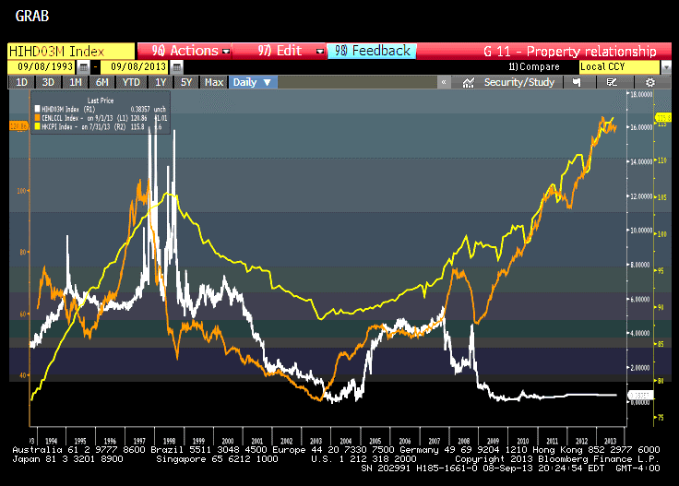years; down. Then, as you can see (flat line on the right) in the period since the GFC they’ve followed a more predictable course with low rates occurring at the same time as rising asset values. So, the relationship between interest rates (at least in this funny little pegged-currency town) and asset prices isn’t a reliable constant.

The relationship between inflation and home prices on the other hand appears to be akin to that of a hand in a glove (there is some circular reference here as the HK CPI contains a large component, c.30%, of property prices via a rental component).

**In conclusion**

Nothing in markets is for sure but if higher rates, or their prospect, were going to impact Hong Kong home prices they should have done so by now. It’s possible that home owners are being the proverbial frogs in the pot that haven’t noticed the water getting hotter? To believe that though I’d have to believe they were either irrational or out of touch; and I don’t believe either.

More likely the calculation is that real assets are worth holding in the event of a small rise in nominal interest rates if the economic climate remains one in which inflation remains persistent.